**G80级起重链条**



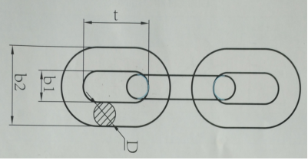

**G80 LIFTING CHAIN G80级起重链条**

**G80 LIFTING CHAIN EN818-2 EN818-2标准起重链条**

|  |  |  |  |  |  |
| --- | --- | --- | --- | --- | --- |
| ITEM NO | WLL/T 工作拉力（t） | D(mm） | t(mm） | b1（mm） min | b2（mm） max |
| 6mm | 1.12 | 6 | 18 | 7.8 | 22.2 |
| 7mm | 1.5 | 7 | 21 | 9.1 | 25.9 |
| 8mm | 2 | 8 | 24 | 10.4 | 29.6 |
| 10mm | 3.15 | 10 | 30 | 13 | 37 |
| 13mm | 5.3 | 13 | 39 | 18.9 | 48.1 |
| 16mm | 8 | 16 | 48 | 20.8 | 59.2 |
| 18mm | 10 | 18 | 54 | 23.4 | 66.6 |
| 20mm | 12.5 | 20 | 60 | 26 | 74 |
| 22mm | 15 | 22 | 66 | 28.6 | 81.4 |
| 26mm | 21.2 | 26 | 78 | 33.8 | 96.2 |
| 32mm | 31.5 | 32 | 96 | 41.6 | 118 |
| 在2.5倍工作拉力下进行验证测试，破断拉力是工作载荷的4倍。 | | | | | |
| **警告：绝对不能超过工作拉力使用** | | | | | |